

18426 Narusorn Phuphanab

**Evaluate and communicate business requirements**

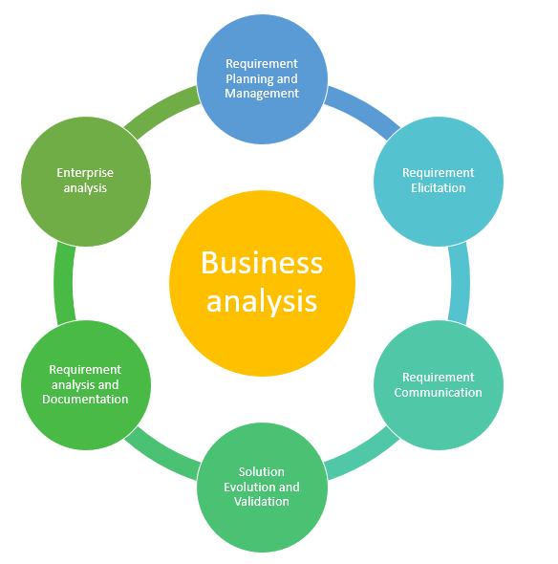

|  |  |  |  |
| --- | --- | --- | --- |
| Name of Student | Narusorn Phuphanab | ID | 18426 |

# Assessment –

# Research & Questioning

Contents

Assessment – 1

Research & Questioning 1

**Instructions:** 1

**Business Scenario** 1

**Task 1: Determine support areas** 2

**Task 2: Identify stakeholders** 3

**Task 3: Develop support procedures** 4

**Task 4: Assign Support Personnel** 6

**Task 5: Short Answer Questions** 6

**Task 6: Multiple Choice Questions** 7

Index 12

#### View My Web Support:

<https://narusorngit.github.io/ecbr18426/>

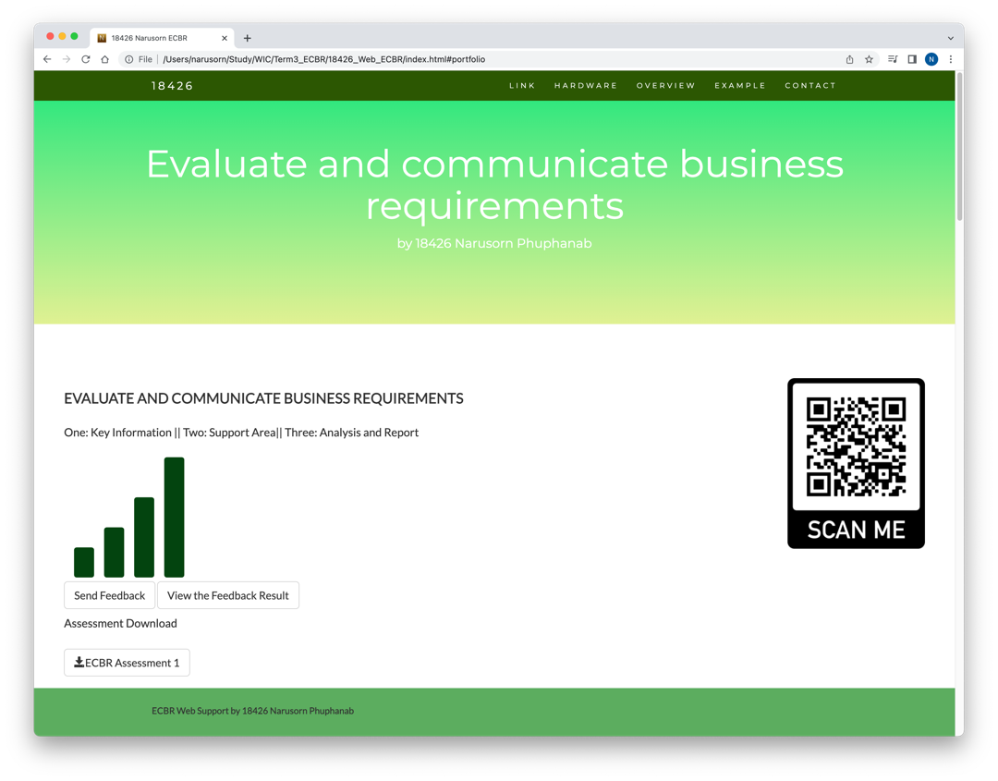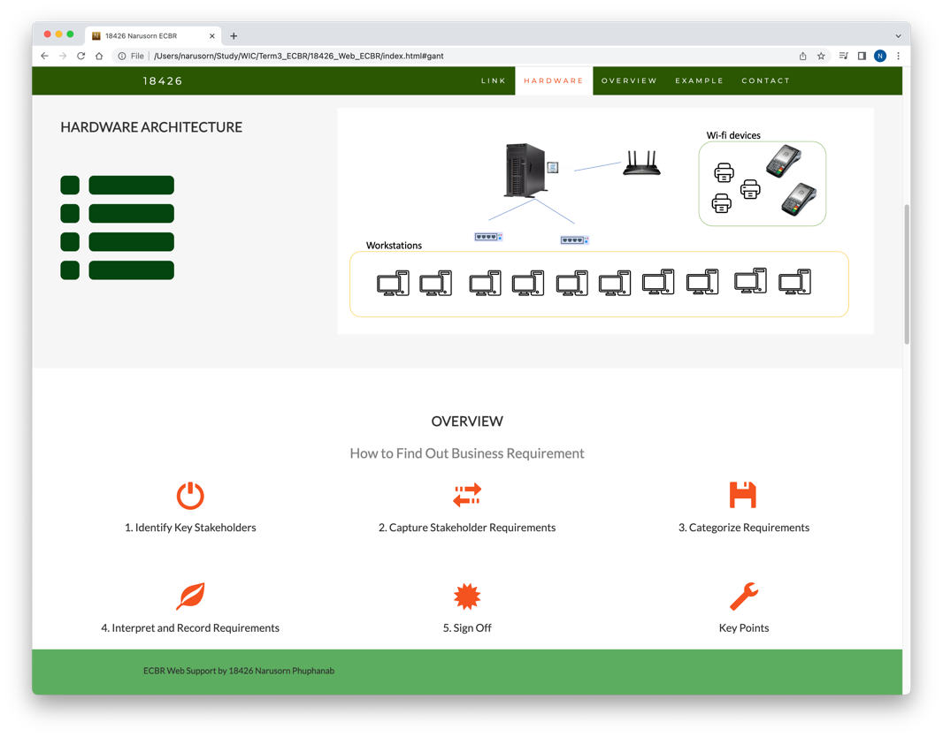

#### *Instructions:*

This assessment is to be completed individually. In this assessment you will be working through a number of written tasks based on case scenarios or research that relate directly to each element of competency for this cluster. Outlined below is information on how each of the tasks relates the element of competency covered.

Learn how to make Google Form: <https://www.youtube.com/watch?v=BtoOHhA3aPQ&t=4s>

Your tasks:

#### *Business Scenario*

D&K Books Pty Ltd is a bookstore owned by Mr. Dean Kerr. The business occupies two levels of an office building connected by escalators and lifts. D&K Books employs approximately six sales staff, one operation manager, two administrative officers, a bookkeeper and a marketing manager. They have an Ethernet network consisting of ten PCs (Intel I3 Desktop cloned), two switches, a router and three printers. They use the QuickBooks software to manage their entire business, including sales, inventory, ordering, accounts receivable, accounts payable, payroll and employee management. They also have two EFTPOS terminals one on each floor.

D&K Books has a Linux server that stores all of the data including the QuickBooks database. The server is backed up to tape regularly. They also have a website (hosted on an Australian ISP’s server, dynamic and static pages using asp.net) on which customers can browse the product catalogue and view current specials. They also lease a telephone system from Live Telecoms. The PABX (phone system) consists of a main switchboard and five remote phones with three incoming lines and a message-on-hold queue system.

System overview (Hardware)

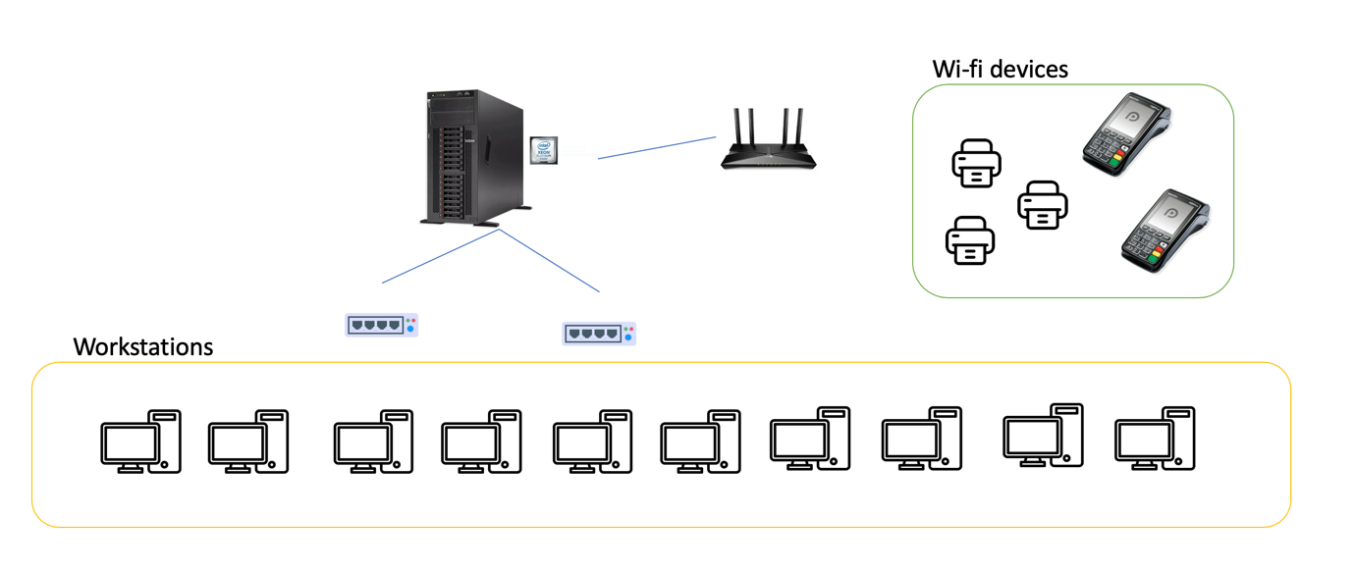

#### *Task 1: Determine support areas*

Identify information technology (HW and SW) and list the technology in use in D&K Books and consider the following:

* What sort of support does the technology require?
* Who is likely to provide this support?
* Does the support arrangement already exist?

Present your answer in a table such as the one below:

|  |  |  |  |  |
| --- | --- | --- | --- | --- |
| **Technology** | **Description** | **Support Required** | **Provider** | **Support Already exists? (Yes/No)** |
| QuickBooks Software | Accounting software installed on the on-premise server | Need an initial setup | [www.intuit.com.au](http://www.intuit.com.au) | Yes |
| Printer | Wi-fi printer | Refill and maintenance | - | Yes (this can be done by admin) |
| Cloud backup | Backup data into a reliable cloud storage | data migration | Google cloud platform | No |
| EFTPOS | A card payment method | - | - | Yes |
| Online payment | Making a payment online or subscriptions | Building a subscription platform | Shopify, stripe | No |
| Delivery service | Delivery books | Hiring a delivery or using online courier provider | Australia post ,  Amazon | No |
| Social network | Business profile or products selling on the social network platforms | Channelling to online social network platforms (this can be done by admin) | Facebook , Instagram, Youtube | No |
| Online advertisement | Pay an online ad provider to promote products | Posting all products to provider (this can be done by sales team or product owner) | Facebook ad | No |
| Telephone system | Low cost | Phone company | Telstra | Yes |
| Website | Low cost | Yes | Godaddy | Yes |
| Network | wireless | No external | No | No |

Please review my website: <https://narusorngit.github.io/ecbr18426/>

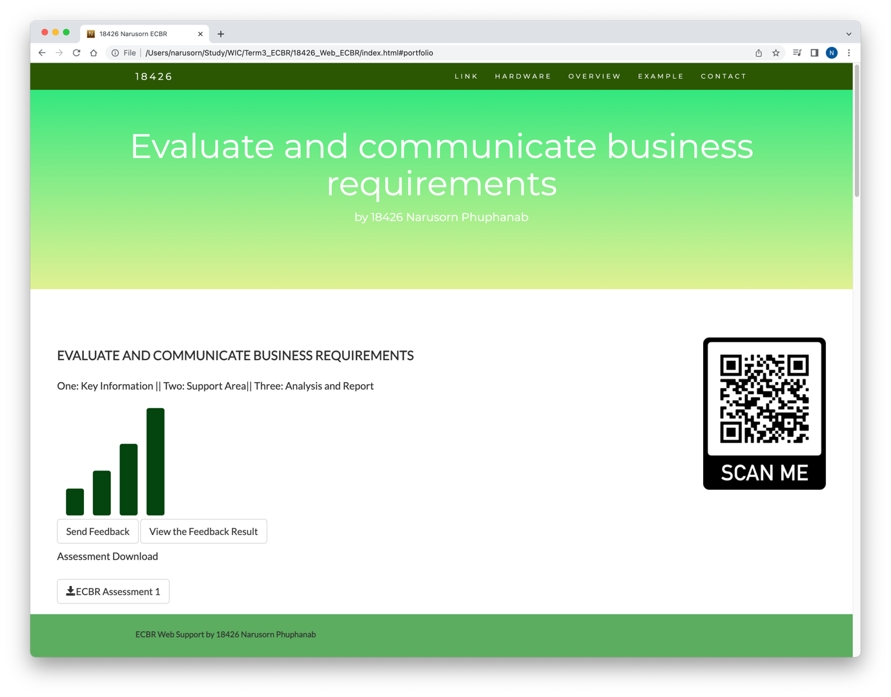

#### *Task 2: Identify stakeholders*

Identify stakeholders related in D&K Books system

All the staffs (the business owner, the relevant manager, the local workers and the remote workers) are stakeholders

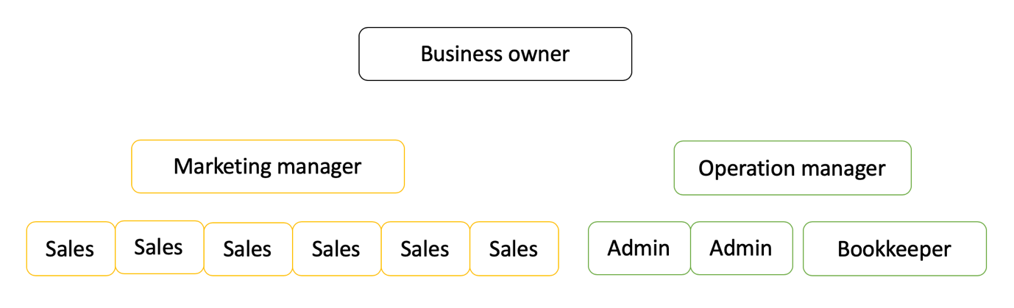

Your comment: This company has a huge sales team. In term of selling physical books, it’s great to enhance the sales team. But, there are many online channels that provide a wide range capability of sales. In my opinion, online platform is a profitable tool that can be knowledgeable for staff by online sources. Developers might be hired to complete this task if there is a shortage of the employees.

#### *Task 3: Develop support procedures*

1. Describe one positive and one negative experience you have had when seeking assistance from a telecommunication company, an ISP or a computer supplier. Your experience may be via telephone, email or even voice recognition.

|  |  |  |
| --- | --- | --- |
| Type | Positive | Negative |
| Telephone | Easy to get answer | Document provide |
| Email | Document, Picture, words or any media | Have to wait |
| Go to company | Face to face get answer | Cost time and money on trip |
| Remote screen access | Easy to handle on specific task real-time | Risk for stealing data from the vulnerability access if it’s done by unprofessional person |
| Technical onsite support | Task can be done in the day | High cost (labour and travel trips) |

1. Using the experiences described above please answer the following questions.
   1. What support aspects were professional and/or unprofessional?
   2. How long did the support process take?
   3. Were the steps logical?
   4. Did they solve your problem?
   5. Was the call deflected to another area?

|  |  |  |
| --- | --- | --- |
| Items | professional | unprofessional |
| What support aspects | Friendly, Listening | Not what know your customer |
| How long | Very quick | Waiting and waiting |
| Steps logical | Yes | No |
| Solve | Good | Can not |
| Another area | If has, need solve | If has, do not care |

Using feedback form or Google survey form.

Survey link: <https://docs.google.com/forms/d/e/1FAIpQLScY4VhiYaX3OC-7Vy9qpw-5bkvRVwuOxkv7h1q6aRPdRUsg9A/viewform>

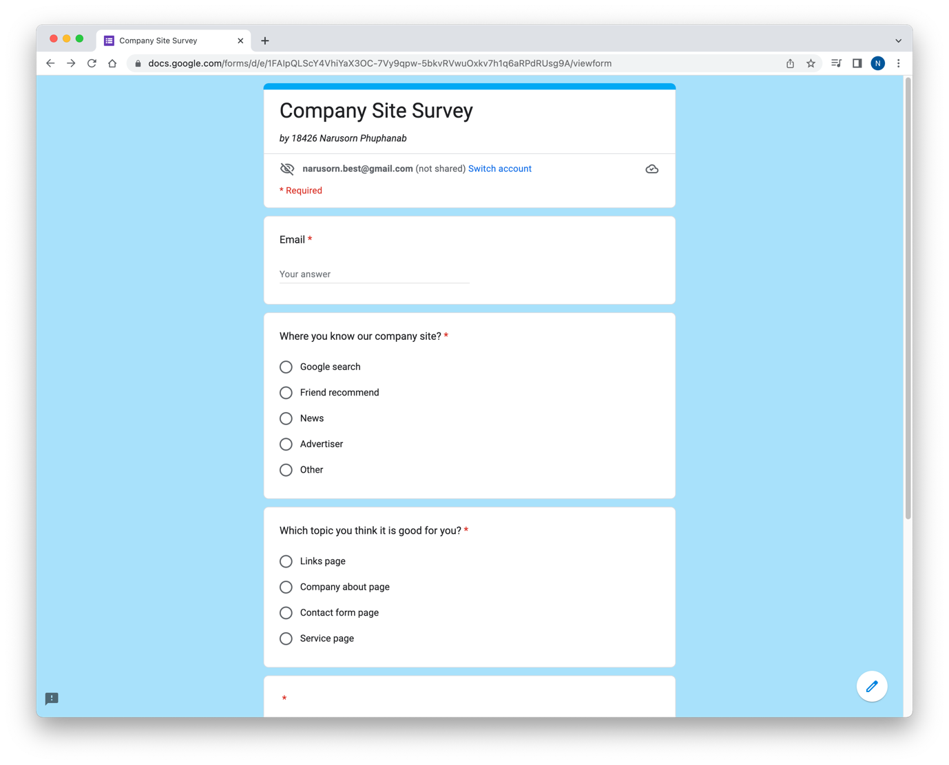

Excel response:

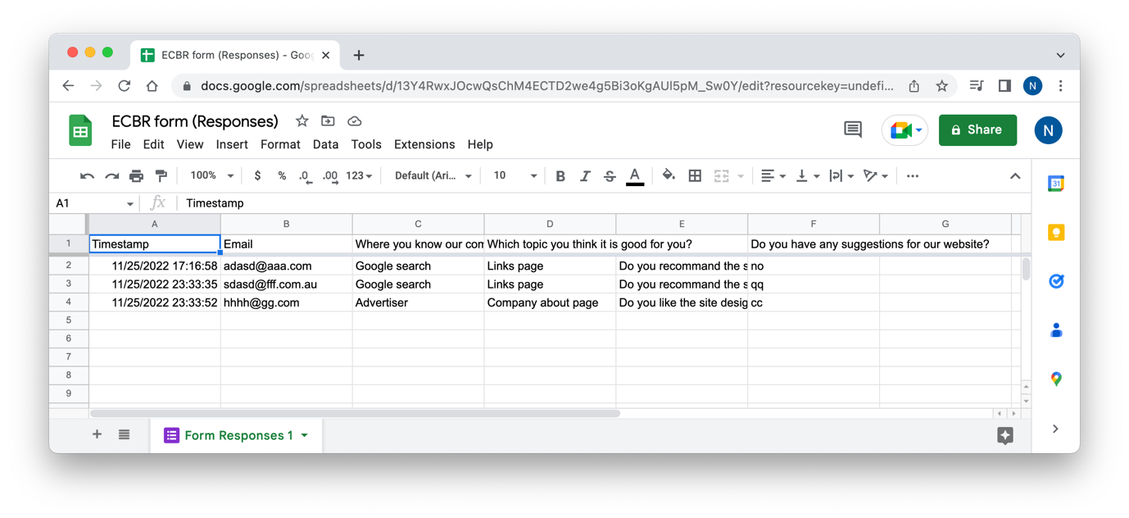

Please review my website: <https://narusorngit.github.io/ecbr18426/>



#### *Task 4: Assign Support Personnel*

Classify the following into soft skills and technical skills. Your answer should take the form of a table shown below.

|  |  |  |
| --- | --- | --- |
| **Skill** | **Soft skill** | **Technical skill** |
| A knowledge of Linux |  | X |
| The ability to work under pressure | X |  |
| The administration of Windows 2008 Server |  | X |
| The ability to formulate network and IT policies |  | X |
| The ability to write network documentation |  | X |
| The ability to give presentations | X |  |

Here is about document reequipment at support website: <https://narusorngit.github.io/ecbr18426/>

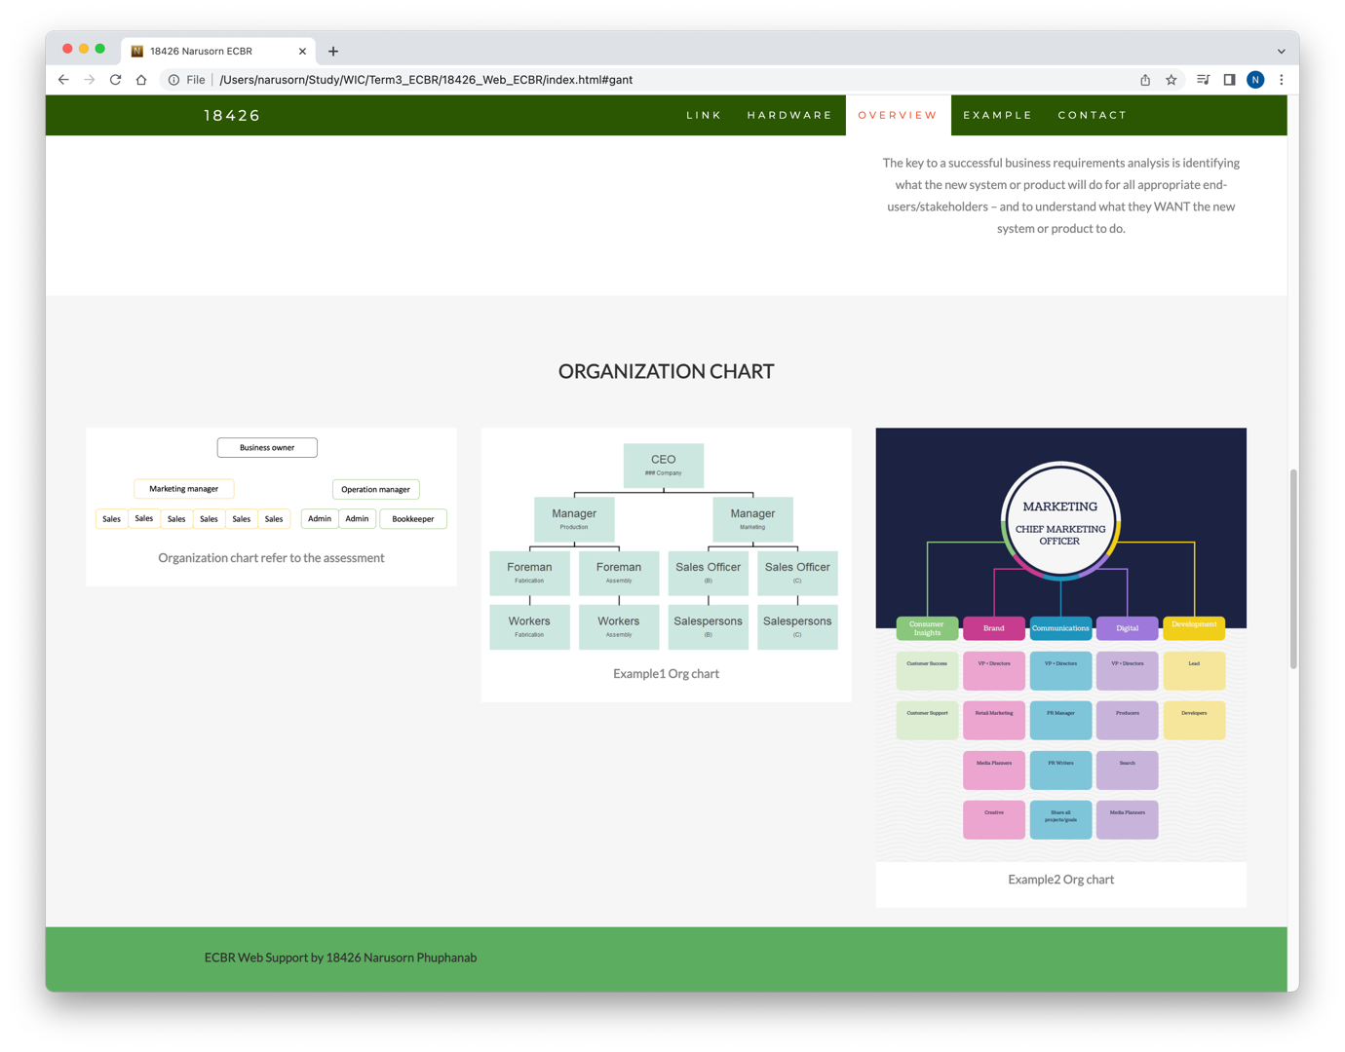

#### *Task 5: Short Answer Questions*

1. 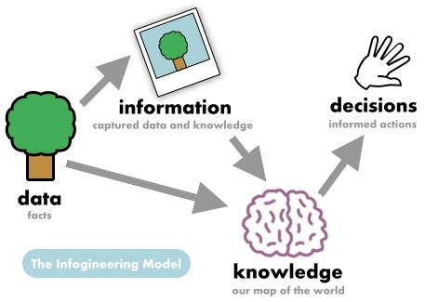Explain the relationship between data, information and knowledge.

Data is fact

Information from data to get means

Knowledge base the information

More knowledge and smarter, so we call wisdom

1. What is quantitative data and how can you use it.

Quantitative data is the value of data in the form of counts or numbers where each data set has a unique numerical value. This data is any quantifiable information that researchers can use for mathematical calculations and statistical analysis to make real-life decisions based on these mathematical derivations.

1. What is qualitative data and how can you use it.

Associated with details, Implemented when data can be segregated into well-defined groups, Collected data can just be observed and not evaluated Examples: Scents, Appearance, Beauty, Colors, Flavors, etc.

Source: https://www.questionpro.com/blog/quantitative-data/

1. Give an example of how quantitative and qualitative data can be used in conjunction with each other

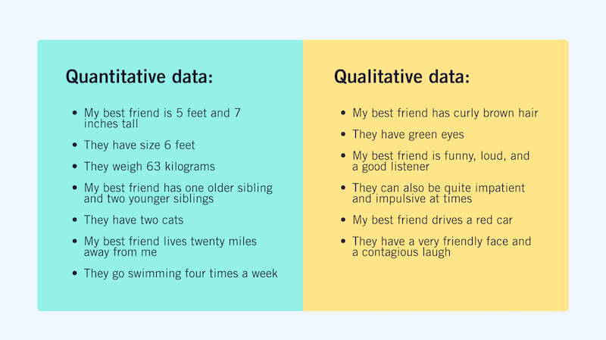

1. What sort of methods could you use to determine client requirements for a website design and key information sources?

* Customer feedback
* Survey
* Features
* Prototyping
* Samples

1. Give some examples of client requirements for a website design

* Theme or colours
* Reliability
* Manageability
* User experience

#### *Task 6: Multiple Choice Questions*

1. Generally, how many points should a rating scale have?
   1. Five
   2. Four
   3. Ten
   4. Somewhere from 4 to 11 points

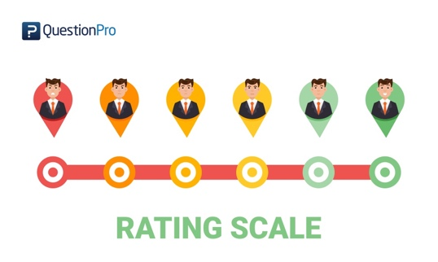

The format of a typical five-level Likert item, for example, could be:

1.Strongly disagree

2.Disagree

3.Neither agree nor disagree

4.Agree

5.Strongly agree

Source: <https://en.wikipedia.org/wiki/Likert_scale>

1. What is the problem(s) with this set of response categories to the question “What is your current age?”

* 1-5
* 5-10
* 10-20
* 20-30
* 30-40
  1. The categories are not mutually exclusive
  2. The categories are not exhaustive
  3. Both a and b are problems
  4. There is no problem with the above set of response categories

Comment: in range 1-5 and 5-10 are smaller than the rest

1. You should mix methods in a way that provides complementary strengths and no overlapping weaknesses. This is known as the fundamental principle of mixed research.
   1. True
   2. False

1. According to the text, questionnaires can address events and characteristics taking place when?
   1. In the past (retrospective questions)
   2. In the present (current time questions)
   3. In the future (prospective questions)
   4. All of the above

Comment: Questioning can be done for requirement collecting by Past/ Present/ Future

1. Which of the following are principles of questionnaire construction?
   1. Consider using multiple methods when measuring abstract constructs
   2. Use multiple items to measure abstract constructs
   3. Avoid double-barrelled questions
   4. All of the above
   5. Only b and c

Comment: a) b) and c) are following are principles of questionnaire construction that refers to the design of a questionnaire to gather statistically useful information about a given topic.

1. Which of these is not a method of data collection?
   1. Questionnaires
   2. Interviews
   3. Experiments
   4. Observations

Comment: Experiment is not done by customer to get information.

1. Secondary/existing data may include which of the following?
   1. Official documents
   2. Personal documents
   3. Archived research data
   4. All of the above

Comment: Official documents, Personal documents and Archived research data are the secondary or existing data.

1. An item that directs participants to different follow-up questions depending on their response is called a ____________.
   1. Response set
   2. Probe
   3. Semantic differential
   4. Contingency question
2. Which of the following terms best describes data that were originally collected at an earlier time by a different person for a different purpose?
   1. Primary data
   2. Secondary data
   3. Experimental data
   4. Field notes
3. Researchers use both open-ended and closed-ended questions to collect data. Which of the following statements is true?
   1. Open-ended questions directly provide quantitative data based on the researcher’s predetermined response categories
   2. Closed-ended questions provide quantitative data in the participant’s own words
   3. Open-ended questions provide qualitative data in the participant’s own words
   4. Closed-ended questions directly provide qualitative data in the participants’ own words

Comment: Open-ended questions often ask for opinion or thoughts.

1. Open-ended questions provide primarily ______ data.
   1. Confirmatory data
   2. Qualitative data
   3. Predictive data
   4. None of the above

Comment: Qualitative data is primarily asked for the open-ended questions

1. Which of the following is true concerning observation?
   1. It takes less time than self-report approaches
   2. It costs less money than self-report approaches
   3. It is often not possible to determine exactly why the people behave as they do
   4. All of the above

Comment: a) and b) are fact

1. Qualitative observation is usually done for exploratory purposes; it is also called ___________ observation.
   1. Structured
   2. Naturalistic
   3. Complete
   4. Probed

Comment: Naturalistic observation is a qualitative research method where you record the behaviors of your research subjects in real world settings. You avoid interfering with or influencing any variables in a naturalistic observation.

Source: [https://www.scribbr.com/](https://www.scribbr.com/methodology/naturalistic-observation/#:~:text=Naturalistic%20observation%20is%20a%20qualitative,people%20watching%E2%80%9D%20with%20a%20purpose.)

1. When constructing a questionnaire, it is important to do each of the following except ______.
   1. Use "leading" or "loaded" questions
   2. Use natural language
   3. Understand your research participants
   4. Pilot your test questionnaire

Comments: There is a distinct difference between leading questions and loaded questions. While a leading question prompts someone toward an answer, a loaded question is a trick question. No matter how a respondent answers, they’re saying something that they may not agree with.

Source: <https://www.surveylegend.com/survey-questions/leading-questions/>

1. Another name for a Likert Scale is a(n):
   1. Interview protocol
   2. Event sampling
   3. Summated rating scale
   4. Ranking

Comment: Likert scales are often called summative scales.

Source: <https://en.wikipedia.org/wiki/Likert_scale>

1. Which of the following is not one of the six major methods of data collection that are used by educational researchers?
   1. Observation
   2. Interviews
   3. Questionnaires
   4. Checklists

Comment: Checklists is not a great indicator leading to a narrow answer.

1. The type of interview in which the specific topics are decided in advance but the sequence and wording can be modified during the interview is called:
   1. The interview guide approach
   2. The informal conversational interview
   3. A closed quantitative interview
   4. The standardized open-ended interview

Comment: the guide approach is intended to ensure that the same general areas of information are collected from each interviewee; this provides more focus than the conversational approach, but still allows a degree of freedom and adaptability in getting the information from the interviewee.

Source:<https://www.public.asu.edu/~kroel/www500/Interview%20Fri.pdf>

1. Which one of the following in not a major method of data collection:
   1. Questionnaires
   2. Interviews
   3. Secondary data
   4. Focus groups
   5. All of the above are methods of data collection
2. A question during an interview such as “Why do you feel that way?” is known as a:
   1. Probe
   2. Filter question
   3. Response
   4. Pilot

Comment: Probe is asked for more deeper information or confirmation.

1. A census taker often collects data through which of the following?
   1. Standardized tests
   2. Interviews
   3. Secondary data
   4. Observations

Comment: Observations are used for a huge group of samples.

1. The researcher has secretly placed him or herself (as a member) in the group that is being studied. This researcher may be which of the following?
   1. A complete participant
   2. An observer-as-participant
   3. A participant-as-observer
   4. None of the above

Comment: This is a fully embedded researcher, almost like a spy. Here the observer fully engages with the participants and partakes in their activities.

Source: <https://measuringu.com/observation-role/>

1. Which of the following is not a major method of data collection?
   1. Questionnaires
   2. Focus groups
   3. Correlational method
   4. Secondary data

Comment: The correlational method involves looking for relationships between variables

Source: <https://www.sciencedirect.com/topics/computer-science/correlational-method>

1. Which type of interview allows the questions to emerge from the immediate context or course of things?
   1. Interview guide approach
   2. Informal conversational interview
   3. Closed quantitative interview
   4. Standardized open-ended interview

Comment: The questionaries ask for few quick question immediately.

1. When conducting an interview, asking "Anything else?, What do you mean?, Why do you feel that way?," etc, are all forms of:
   1. Contingency questions
   2. Probes
   3. Protocols
   4. Response categories

Comment: More information

1. When constructing a questionnaire, there are 15 principles to which you should adhere. Which of the following is not one of those principles?
   1. Do not use "leading" or "loaded" questions
   2. Avoid double-barrelled questions
   3. Avoid double negatives
   4. Avoid using multiple items to measure a single construct

Comment: a), b) and c) are in the 15 principles

1. A customer-based Service Level Agreement structure includes:
   1. An SLA covering all Customer groups and all the services they use
   2. SLAs for each service that are Customer-focused and written in business language
   3. An SLA for each service type, covering all those Customer groups that use that Service
   4. An SLA with each individual Customer group, covering all of the services they use

Comment: An SLA with each individual Customer group, covering all of the services they use

1. Which of the following best describes the goal of Service Level Management?
   1. To maintain and improve IT service quality in line with business requirements
   2. 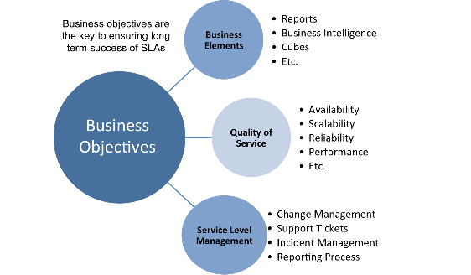To provide IT services at the lowest possible cost by agreeing with Customers their minimum requirements for service availability and ensuring performance does not exceed these targets
   3. To provide the highest possible level of service to Customers and continuously improve on this through ensuring all services operate at maximum availability
   4. To ensure that IT delivers the same standard of service at the least cost

Comment: Service Level Manager is responsible for negotiating Service Level Agreements and ensuring that these are met

Source: <https://wiki.en.it-processmaps.com/index.php/Service_Level_Management>

1. The process to implement SLAs comprises of the following activities in sequence:
   1. Draft SLAs, catalogue services, review underpinning contracts and OLAs, draft SLRs, negotiate, agree SLAs
   2. Draft SLAs, review underpinning contracts and OLAs, negotiate, catalogue services,
   3. Review underpinning contracts and OLAs, draft SLAs, catalogue services, negotiate, agree SLAs
   4. Catalogue services, establish SLRs, review underpinning contracts and OLAs, negotiate service levels, agree SLAs

Comment: Catalogue services > establish SLR > review underpinning contracts and OLA > negotiate service levels > agree SLAs

1. Which of the following is an example of a service level agreement (SLA) between information systems support unit and a research unit in the laboratories of a large company?
   1. The maximum response time to get the system operational should it fail.
   2. The minimum ‘up-time’.
   3. The types of information that will be provided as standard.
   4. All of the above.

Comment: All of these are the following is an example of a service level agreement (SLA) between information systems support unit and a research unit in the laboratories of a large company

1. Some organisations bring a degree of formality to the internal customer concept by encouraging (or requiring) different parts of the operation to agree on:
   1. Internal service agreements
   2. Service level agreements
   3. Formal provision agreements
   4. Delivery agreements

Comment: A service level agreement (SLA) is a documented agreement between a service provider and a customer that identifies both the services required and the expected level of service. The agreement varies between vendors, services, and industries.

Source: <https://www.bmc.com/blogs/sla-template-examples/>

## Index

B

bookstore 3

C

categories 11

closed-ended 12

D

data collection 14

L

Linux server 3

N

negative experience 6

network 3

O

open-ended 12

S

Service Level 14

service level agreement 15

service quality 14

soft skills 9

support 6

T

technology 4

telecommunications 6